

Premier Medical Necessity (PMN) (8.2)

Please read entire document before installing

System and software prerequisites
- This install process must be run over the MS4® 25.40 or higher data files with 26.20 recommended.
- You must be on v8 or higher of PMN before installing this release.
- Your i5/OS must be at V5R3M0 or higher for this release to function properly.
- This release combines v8 with v8.2

Any program found in your HS library that is also found in the release library will need to be manually updated from the release library.

Download/Upload of save file and restore library

The save file for PMN v8.2 can be downloaded from http://www.premsoft.com/PMNV82

The zipped file downloaded from the web page will need to be unzipped and the save file uploaded to your System i5 (iSeries) after which the release library will need to be restored. There are several methods you can use to accomplish this. Below is an example of using FTP to do so.

- Extract the file pmn82.savf to a temporary directory. We’ll use c:\temp in this example.
- Create a save file on your System i5.
CRTSAVF FILE(QGPL/PMN82)
- Open a DOS window and type “cd c:\temp”

- In the same DOS window, use the 'ftp' command in Windows, to FTP 'pmn82.savf' into PMN82 in QGPL. Be sure to use the 'bin' command to change to binary mode. Here is a sample FTP session:
C:\temp>ftp nnn.nnn.nnn.nnn
Connected to nnn.nnn.nnn.nnn.
220-QTCP at (System i5 name).
220 Connection will close if idle more than 5 minutes.
User (nnn.nnn.nnn.nnn:(none)): userid
331 Enter password.
Password: XXXXX
230 USERID logged on.
ftp> bin
200 Representation type is binary IMAGE.
ftp> put pmn82.savf QGPL/PMN82
200 PORT subcommand request successful.
150 Sending file to member PMN82 in file PMN82 in library QGPL.
250 File transfer completed successfully.
8668704 bytes sent in 22.76seconds 380.19Kbytes/sec)
ftp> quit
221 QUIT subcommand received.

- From a System i5 command line, run the following command.

RSTLIB SAVLIB(PMN_V8.2) DEV(*SAVF) SAVF(QGPL/PMN82)

- On the same command line, run the following command.

DLTF FILE(QGPL/PMN82)

Begin Installation

- Sign on to your System i5 with a user profile that has at least SECADM authority.
- Set your library list for the PMN environment. Should include PH/MR/EC.
- Add the release library to your library list (PMN_V8.2)
- On a command line type $_install and press enter.

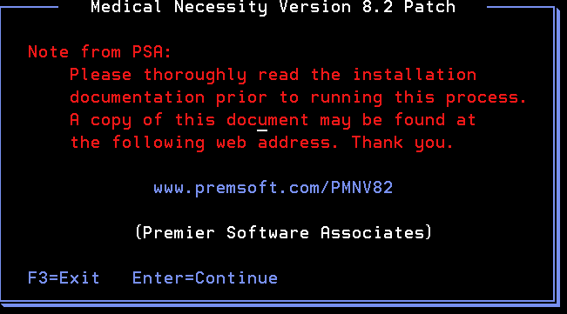

  - The installation will now begin.
  - Base Library = Library containing current version of PMN that will be updated to v8.2.
  - Release Library = Library restored from the downloaded save file.
  - Additional Library = A data library that would need to be updated. This would be for multiple entity environments. You would add each entities PMN data library here.

- Press F5 to start the install process. 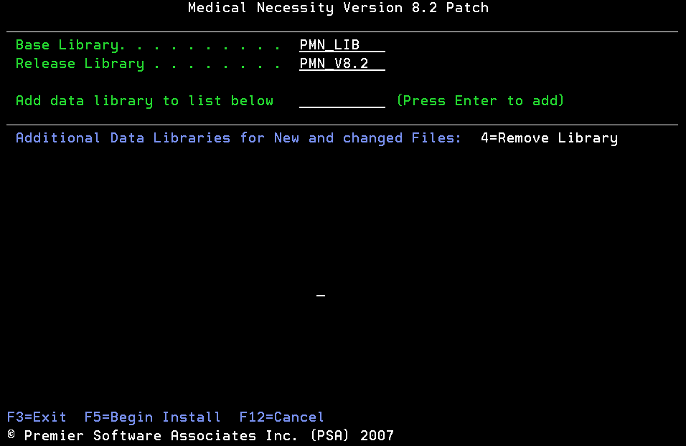
- If you entered additional libraries, the following screen will display allowing you to change where the new files are added. 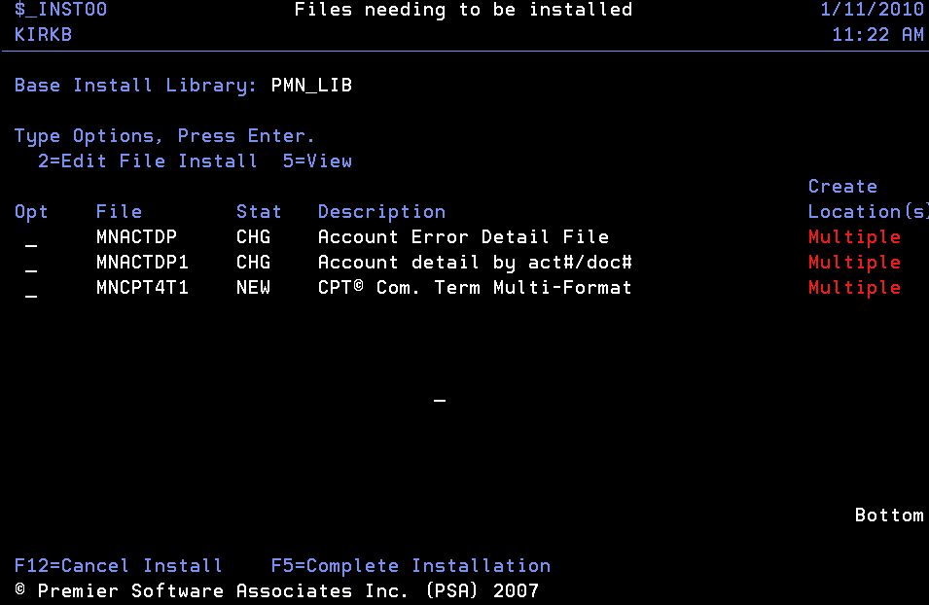

- After pressing F5 from the following confirmation window displays. 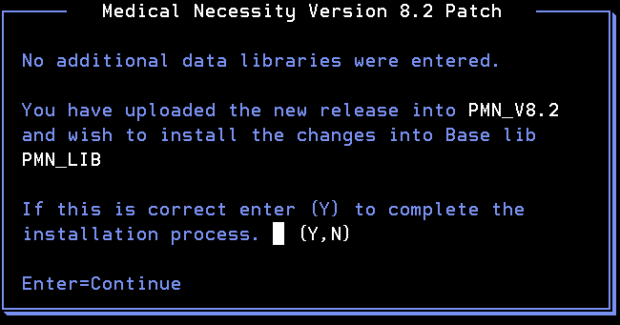

- Enter a “Y” and press enter to install the release.
- When the installation is complete the following window displays.


- The file $_INSTERP may contain three records of logical files that are new to version 8. These records do not indicate an error in the installation.

